Introduction
This user guide describes the Digilent AXI DPTI Intellectual Property. The purpose of this IP is to implement an interface between DPTI and AXI4 Stream. This interface will be controlled using Microblaze via control and status registers and it will theoretically be capable of speeds up to 480 megabits per second.
IP quick facts
Supported device families | Zynq®-7000, 7 series
Supported user interfaces | Xilinx: AXI4 Lite, AXI4 Stream  Digilent: DPTI
Provided with core
Design files | VHDL
Simulation model | N/A
Constraints file | XDC
Software driver | Standalone
Tested design flows
Design entry | Vivado™ Design Suite 2015.4
Synthesis | Vivado Synthesis 2015.4

Features
- Provides high-speed bidirectional data transfers
- Implements 3 AXI4 Lite registers: 2 for control, 1 for status
- AXI DMA – style length register
- Supports transfer sizes of up to 8 MB

Performance
The IP will transfer data between the DPTI protocol and AXI4 Stream. It is a half-duplex synchronous interface working on the DPTI clock generated by the FTDI chip. Data is passed via an 8bit bidirectional data bus, when the handshake signals allow it, on each rising edge of the 60MHz clock.
The AXI4 Stream interface implemented by the IP is comprised of a 32bit wide TDATA bus, 4bit TKEEP bus and the TREADY, TVALID and TLAST signals. The maximum transfer rate is 480 megabits per second, the same as for the USB 2.0 High Speed protocol.
The IP consists of several individual modules as can be seen in Figure 1, the most important parts being the two converters: DPTI to AXI4 Stream and AXI4 Stream to DPTI. Two AXI4 Stream FIFOs are used for clock domain crossing, both of them with the minimum depth of 16. The AXI4 Lite registers are synchronized using the “HandshakeData” module for the control registers and “SyncAsync“ for the status register.

Overview
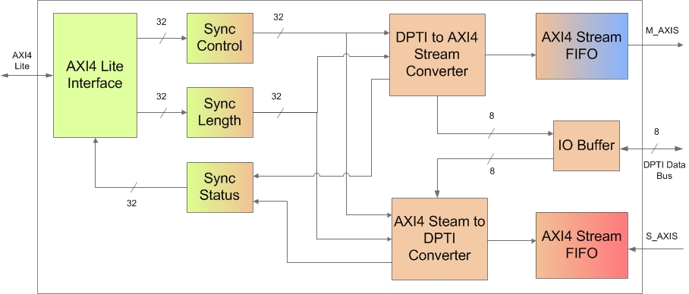
Figure 1. AXI DPTI block diagram.
The IP is built from multiple blocks and has 4 clock signals, one for each of the interfaces involved in the core as depicted in the image, most of the logic being driven by the FTDI clock.

DPTI protocol
A “Write” transfer is performed when data is sent from the FPGA to the FTDI chip using the PROG_TXEN – PROG_WRN signals. When data is moved in the other direction, a “Read” transfer is performed and the handshake signals in this case are PROG_RXFN – PROG_RDN. A fifth signal called PROG_OEN is used to inform the FT2232H regarding the transfer direction: low when reading and high when writing data. PROG_OEN, PROG_RDN and PROG_WRN are generated by the IP and PROG_RXFN and PROG_TXEN by the FTDI IC.

AXI4 Lite registers
The AXI DPTI core implements two control registers and one status register which can be accessed using the AXI4 Lite interface. The first register is used for writing the transfer length and it uses the base address. The next register is used for the IP core’s control. And the third one is the status register.
Address Space Offset | Name | Description
00h | Length | AXI DPTI transfer length in bytes
04h | Control | AXI DPTI transfer direction
08h | Status | AXI DPTI status
Table 1. AXI4 Lite register space

Control register
31 | 2 | 1 | 0
Rx Control Bit
Tx Control Bit

Length register
31 | Not used | 23 | 22 | 0

Length [22:0]

Status register
31 |  | 17 | 16 | 15 |  | 1 | 0
Tx Status Bit
Rx Status Bit

Transfer control
Transfers will be performed by first configuring the Control register, setting the direction. Only one converter can work at a given time since DPTI is a half-duplex interface. In order to enable a converter, the corresponding bit must be set to 1 while the other converter must be disabled. For “Write” transfers bit 0 will be asserted and bit 1 will be de-asserted; for “Read” transfers bit 1 will be de-asserted and bit 1 will be asserted.
After the transfer direction has been selected, writing the Length register will determine the transfer to start. While the core is busy, the transfer direction cannot be changed. After the transfer was completed, another transfer in the same direction can be performed without needing to write the control register again.
The status of the IP can be determined by reading the status register. Bits 0 and 16 of this register will each inform the user about the state of each of the converters. A true value will indicate an available module. Both bits must be true in order for a new transfer to be requested.

Port descriptions
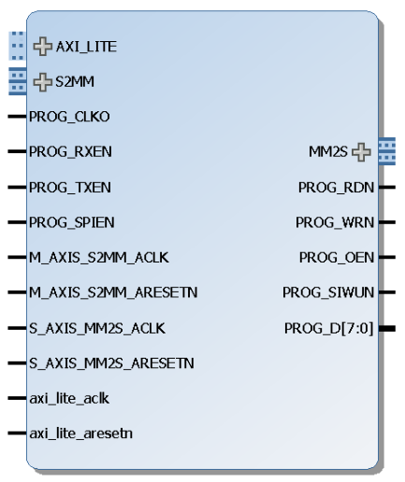
Figure 2. AXI DPTI IP Core.
The table below will present the signals and interfaces implemented by the AXI DPTI core.
Signal Name | Interface | Signal Type |  |  |  | Init State | Description
PROG_CLKO | DPTI | Input |  |  |  | N/A | DPTI protocol clock signal
PROG_RXEN | DPTI | Input |  |  |  | N/A | When low, indicates that the slave has data available for transfer
PROG_TXEN | DPTI | Input |  |  |  | N/A | When low, indicates that the slave can accept a new data transfer
PROG_SPIEN | DPTI | Input |  |  |  | N/A | SPI enable
PROG_RDN | DPTI | Output |  |  |  | N/A | Read signal. When low, data byte is valid.
PROG_WRN | DPTI | Output |  |  |  | N/A | Write signal. When low, data byte is valid.
PROG_OEN | DPTI | Output |  |  |  | N/A | Output enable signal. Determines transfer direction
PROG_SIWUN | DPTI | Output |  |  |  | N/A | Send Imediate / Wake-up signal
PROG_D [8] | DPTI | Input / Output |  |  |  | N/A | Bidirectional data bus
M_AXIS_S2MM_ACLK | MM2S | Input |  |  |  | N/A | MM2S interface clock signal
S_AXIS_MM2S_ACLK | S2MM | Input |  |  |  | N/A | S2MM interface clock signal
axi_lite_aclk | AXI_LITE | Input |  |  |  | N/A | AXI_LITE interface clock signal
M_AXIS_S2MM_ARESETN | MM2S | Input |  |  |  | N/A | M2SS
S_AXIS_MM2S_ARESETN | S2MM | Input |  |  |  | N/A | S2MM reset signal
axi_lite_aresetn | AXI_LITE | Input |  |  |  | N/A | AXI_LITE reset signal
AXI4 Lite Interface Signals
AXI_LITE* |  |  | Input / Output | AXI4 Lite interface used to communicate with the control and status registers
AXI4 Stream Interface Signals
S2MM* |  |  | Input |  | AXI4 Stream interface - input for data which will be converted to the DPTI protocol
MM2S* |  |  | Output |  | AXI4 Stream interface - output for data which has been received from the DPTI port
Table 2. Port descriptions

Designing with the core

Constraints
The AXI DPTI core includes the timing constraints needed for the DPTI protocol for boards where the signal traces are equal in length. The HandshakeData and SyncAsync modules are also constrained.
An out-of-context XDC file is included which will provide constraints for the AXI4 Stream clock signals.

References
The following documents provide additional information on the subjects discussed:
- Xilinx Inc., UG471: 7 Series FPGAs SelectIO Resources, v1.4, May 13, 2014.
- Xilinx Inc., UG472: 7 Series FPGAs Clocking Resources, v1.6, October 2, 2012.
- Xilinx Inc., UG903: Using Constraints, v2014.3, October 31, 2014
- Xilinx Inc., PG021: AXI DMA logiCORE IP Product Gudie, v7.1, november 18, 2015
- FTDI, FT2232H Dual High Speed USB to Multipurpose UART/FIFO IC, v2.5
- FTDI, AN_165: Establishing Synchronous 245 FIFO Communications using a Morph-ICII, v1.1, June 26,2012

